**PATIENT HEALTHCARE MANAGEMENT SYSTEM**

**1.Abstract**

With the development of technology around us in every domain, as well as the advancement of lifestyle, the demand medical services is rapidly increasing. As a medical center, the efficiency of the operation, the effective allocation and utilization of resources are very important. However, in the current routine of the healthcare system, there are many messy and traditional storage methods, which are not conducive to efficient use of resources and may increase the risk of mistakes.

Therefore, an effective technologically supported healthcare system is the need of the hour, which will help provide advanced healthcare services to patients all across the country. It is essentially necessary to provide a platform that supports paperless mechanism and in turn enables lower risks of mistakes.

Keyword—Patient,Doctor,Test,medical information,insurance

**2.Assumption**

We have following assumption:

1. HIPAA compliance which sets national standards for protecting the confidentiality, integrity, and availability of electronic protected health information is adhered.
2. NERC-CIP compliance , standards require utility companies in North America to establish and adhere to a baseline set of cybersecurity measures.

**3.project content**

**Introduction:**

We are on a mission to establish a Patient centric healthcare management mobile and web application where a patient can access healthcare services in just a single click. The application aims to use technology to not only enable patients to explore and choose from various health care providers, but also facilitate a medium to store information that can be shared with different doctors, without having to fill out forms in every single appointment.

**Objectives:**

1. Establish patient’s unique identity across different healthcare providers within the healthcare ecosystem through a 14-digit identification number.
2. Provide a centralized platform for patients to access healthcare benefits in their region.
3. Enable the patient to book appointments quickly through web and avoid long queues.
4. Providing additional value-added service:
   1. Link all healthcare benefits ranging from public health programs to insurance schemes.
   2. Access to Healthcare Professional Registry which is a compilation of the details of all the doctors in the State health services.
   3. Access to the Health Facility Registry from NIH (National Institutes of Health) which is a list of all the medical facilities.

**ER-diagram:**

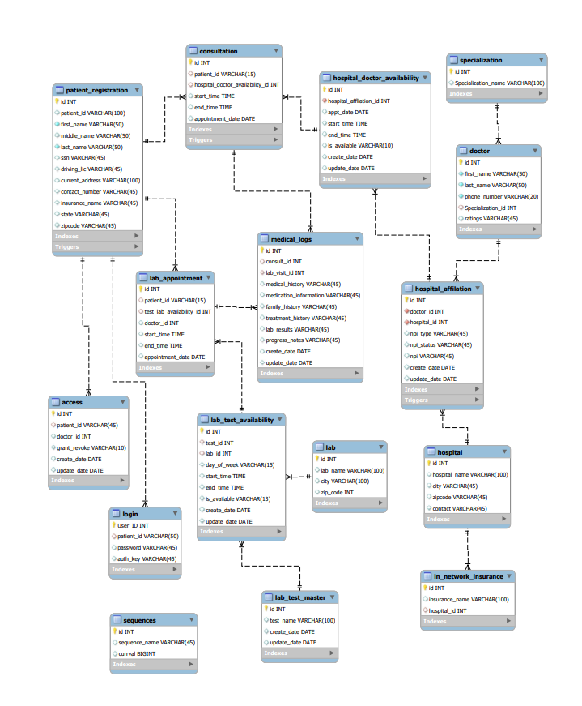

**4.conclusion**

**Benefits:**

1. **Digitized health records**  
   Patients access all their medical information like tests, diagnoses, medicine prescriptions, etc., with just a few clicks.
2. **Access to doctors**  
   Patients can share their medical records easily with hospitals, clinics, doctors, etc. Thus, they can get medical care even in new localities.
3. **Personal health records**  
   With patients’ digital health ID number, they can link their personal health records. This will help to generate a long-term medical history.
4. **Consent**  
   Doctors or other health professionals can see patients’ data only after they grant consent.
5. **Security**  
   Strong encryption and security are the base of this digital platform. Patients also have control over who can and cannot access your health records.
6. **Easy sign up**  
   To generate unique 14-digit ID number patient will only need their basic details and SSN or driving license number. Alternatively, patients can also register with their mobile number.
7. **Voluntary activation and de-activation**  
   Patient can also opt-out and erase their data from with ease.

**Challenges with the existing system:**

1. As Conventional data acquisition practices are persistent in most parts of the country that can make it extremely challenging to track the past health records of any individual and increase the possibility of errors such as inaccurate reporting, inconsistent language and duplication of records.
2. In addition, collecting and storing the confidential information is a hurdle for physicians, particularly when a patient is dependent on several healthcare centers for treatment.
3. Having difficulty getting details about the doctor’s expertise and scheduling a consultation based on their availability and location.
4. Prescriptions for ongoing treatments and records of earlier physical lab tests are likely to be misplaced and thus need to provide all the medical history that can carry the risk of missing out some important details.
5. Need to provide all the medical history details while making a new consultation and chances of missing some when patients require services from multiple healthcare providers.
6. Some patients could feel concerned disclosing their personal information.